**BASE BULIDING**

**ASSIGNMENT**

***ASSIGNMENT QUESTION***

**Q1:-** *What is Padding and Margin and When do you use them ?*

**ANS:- PADDING:-***Padding is the space between the content and the border of an element. Padding is valuable in making additional space inside an element, keeping it at a set distance from other aspects of a website. Using padding is extremely beneficial when you need to separate text boxes and images while also keeping them aligned.*

**MARGIN :-** Margin is the space around the border of an element. The margin surrounding an element will inform the web browser being used of how much space should be left between independent elements and the external margin of the website's page. Margins can also be used to keep different elements an equal distance apart.

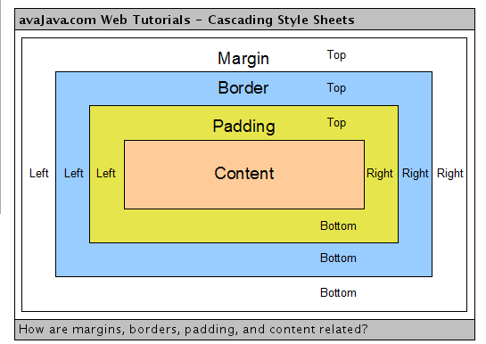

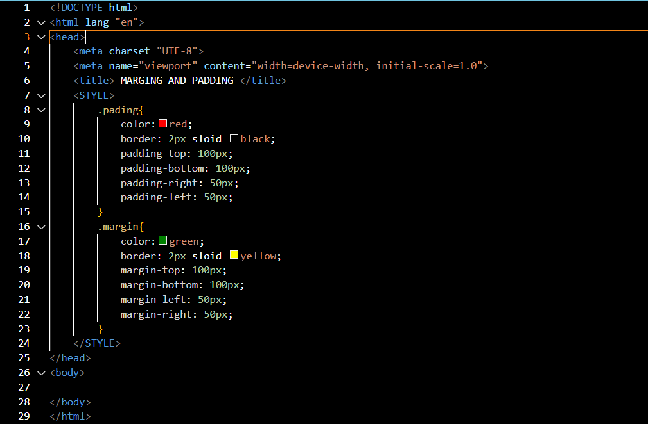

**Q2**:- What is display property and display inline, block , and inline block ?  
**ANS:-** The display property specifies the display behavior (the type of rendering b  ox) of an element.

In HTML, default display property value is taken HTML specification or form browser / user default style sheet . The default value in XML is inline is including SVG element.

1. Display-none
2. Display-block
3. Display-inline-block
4. Display- inline

## Q3:- Explain min-height , max-height, max-width,min-width ? ANS:- The Max-width Property

The max-width property lets you specify an element's maximum width. This means that an element can increase in width until it reaches a specific [absolute or relative unit](https://www.freecodecamp.org/news/css-unit-guide/), at which point it should fix its width to that unit.

## The Min-Width Property

In contrast to the max-width property, the min-width property specifies the minimum width. It indicates the minimal possible width for an element.

## The Max-Height Property

The max-height property operates similarly to the max-width property, but it affects the height instead of the width

## The Min-Height Property

In contrast to max-height, the min-height property provides a minimum height for an element.